**AI ENABLED NETWORK TRAFFIC ANALYSIS FOR EFFICIENT DATA COMMUNICATION**

Aditya Kumar Nisha Singh

229302290 229302277

Manipal University Jaipur Manipal University Jaipur

Jaipur, India Jaipur, India

[aditya.229302290@muj.manipal.edu](mailto:aditya.229302290@muj.manipal.edu) [nisha.229302277@muj.manipal.edu](mailto:nisha.229302277@muj.manipal.edu)

Abstract:

Innovative solutions are required to provide secure and efficient data transmission due to the exponential expansion of data traffic and the rapid evolution of digital communication. Artificial Intelligence (AI) has become a potent instrument for improving network traffic monitoring, with the potential to maximize data transfer across a range of industries. To achieve effective data communication, this review article offers a thorough overview of current developments in AI-enabled network traffic analysis and its applications.

Introduction:

The contemporary digital landscape is marked by an unprecedented surge in data generation and communication, fueled by the ubiquity of interconnected devices, cloud services, and emerging technologies. As the volume, variety, and velocity of data traffic continue to escalate, traditional methods of network traffic analysis find themselves challenged to meet the demands of an increasingly dynamic and complex networking environment. Efficient data communication, a cornerstone of modern technological ecosystems, necessitates innovative approaches to ensure not only the seamless flow of information but also the robustness and security of networks.

In response to these challenges, Artificial Intelligence (AI) has emerged as a transformative force, offering unparalleled capabilities in deciphering intricate patterns, predicting trends, and adapting to evolving network dynamics. The integration of AI into network traffic analysis presents a paradigm shift from conventional methodologies, promising enhanced insights, proactive management, and optimized resource allocation. This review seeks to provide a comprehensive exploration of the role of AI in reshaping network traffic analysis and, consequently, revolutionizing the landscape of efficient data communication.

As we embark on this exploration, it is crucial to recognize that the infusion of AI into network traffic analysis is not merely a technological advancement; it signifies a fundamental shift in our approach to managing the intricate interplay of data in the digital realm. By delving into the nuances of AI models, their applications, challenges, and real-world implementations, this review aims to provide a comprehensive understanding of the transformative power of AI in shaping the landscape of efficient data communication.

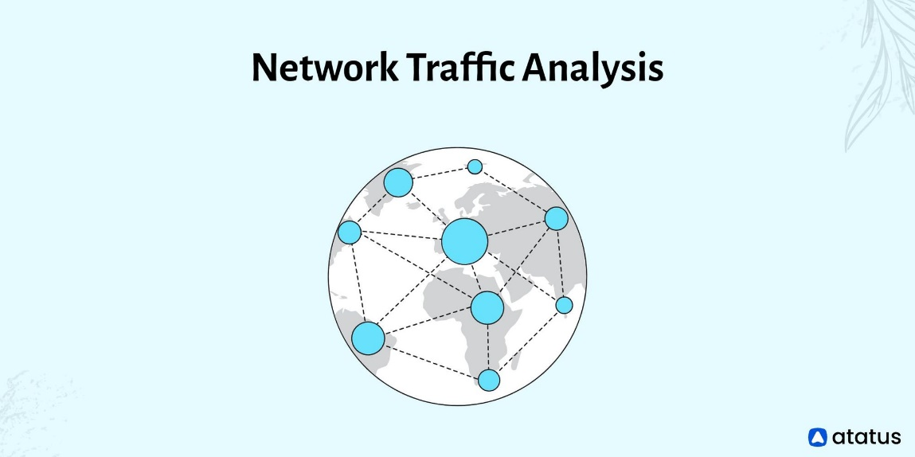 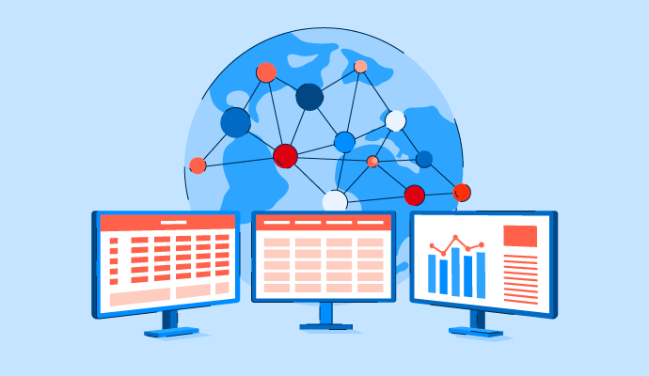

Problem Statement:

The escalating growth of data traffic in contemporary network environments has outpaced the efficacy of traditional network traffic analysis methods. The conventional rule-based and signature-based approaches, once stalwarts in managing network dynamics, are now grappling with the complexities introduced by the surge in connected devices, diverse applications, and evolving communication patterns. This disjunction is particularly pronounced in the face of emerging challenges, including the proliferation of Internet of Things (IoT) devices, increased demand for real-time communication, and the persistent threat landscape of cyber-attacks.

Addressing these challenges necessitates a paradigm shift in network traffic analysis methodologies. Artificial Intelligence (AI) offers a promising avenue by providing adaptive, learning-based models capable of discerning complex patterns, predicting trends, and dynamically optimizing network parameters. This review seeks to explore the potential of AI in mitigating these challenges and fostering efficient data communication in the face of the evolving demands of the digital era.

Applications Of AI In Network Traffic Analysis:

This section explores various applications of AI in network traffic analysis, including:

* **Anomaly Detection:** Discusses how machine learning algorithms can identify abnormal patterns in network traffic, signalling potential security threats or performance issues.
* **Predictive Analytics:** Explores the use of AI models to predict future network traffic trends, facilitating proactive network management and resource allocation.
* **Quality of Service (QoS) Optimization:** Examines how AI can enhance QoS by dynamically adjusting network parameters based on real-time traffic conditions.
* **Traffic Classification:** Discusses the role of AI in accurately classifying different types of network traffic, enabling more precise bandwidth allocation.

AI Models In Network Traffic Analysis:

This section delves into the specific AI models employed in network traffic analysis, such as:

* **Machine Learning Algorithms:** Reviews the use of supervised and unsupervised learning techniques for tasks like classification, clustering, and regression in network traffic analysis.
* **Deep Learning Models:** Explores the application of deep neural networks, including convolutional neural networks (CNNs) and recurrent neural networks (RNNs), in extracting complex patterns from network data.
* **Reinforcement Learning:** Discusses how reinforcement learning can be utilized for adaptive decision-making in dynamic network environments.

Challenges & Future Directions:

Examines the current challenges in implementing AI-enabled network traffic analysis, such as data privacy concerns, model interpretability, and the need for large, labeled datasets. Proposes potential avenues for future research and development to overcome these challenges.

Case Studies & Real-World Implementations:

Provides insights into successful case studies and real-world implementations of AI-enabled network traffic analysis across different industries. Discusses the impact on efficiency, security, and overall network performance.

Conclusion:

In the ever-expanding realm of data communication, the fusion of Artificial Intelligence (AI) with network traffic analysis proves to be a game-changer. Traditional methods are struggling to cope with the dynamic demands of modern networks, but AI offers adaptive solutions.

AI excels in anomaly detection, predicting trends, optimizing Quality of Service (QoS), and classifying diverse traffic types. These applications promise enhanced security, proactive management, and efficient resource allocation.

Despite its transformative potential, challenges like model interpretability, ethical considerations, and integration complexities persist. Future research should focus on refining AI models, exploring decentralized approaches, and bolstering cybersecurity measures.

Real-world implementations underscore the practical impact of AI in diverse industries. In essence, the synergy of AI and network traffic analysis charts a course toward a more intelligent, resilient, and efficient era of data communication.

Future Scope:

* **Interpretability and Trust:** Enhance AI model interpretability for better understanding and trust in decision-making processes.
* **Decentralized Approaches - Federated Learning:** Explore federated learning for privacy-preserving AI model training in decentralized networks.
* **Cybersecurity Advancements:** Develop AI-driven solutions for proactive detection and mitigation of evolving cyber threats.
* **Adaptation to Emerging Technologies:** Investigate how AI-enabled network traffic analysis can adapt to 5G, edge computing, and quantum computing.
* **Energy-Efficient AI Models:** Design models that balance computational efficiency and performance to address sustainability concerns.
* **User-Centric QoS Optimization:** Explore user-centric approaches for personalized Quality of Service (QoS) optimization.
* **Cross-Domain Collaboration:** Foster interdisciplinary collaboration for responsible AI development, involving academia, industry, and regulators.

Acknowledgement:

We would like to express our sincere gratitude to Dr. Vivek Kumar Verma on behalf of the entire team for his tremendous support and direction during the research process that resulted in the conclusion of our article, “ AI ENABLED NETWORK TRAFFIC ANALYSIS FOR EFFICIENT DATA COMMUNICATION “ Your knowledge, guidance, and commitment have been extremely important in determining how our research has progressed. Not only have your helpful critiques and encouraging recommendations improved the calibre of our work, but they have also made a substantial contribution to our professional and academic development.

We sincerely appreciate the time and work you took to evaluate our work, offer insightful commentary, and guide us through the challenges of the research environment. This project has been completed successfully thanks in large part to your mentoring.

We are truly fortunate to have had the opportunity to work under your guidance, and we acknowledge the immense impact your support has had on the outcome of our research endeavour.

Thank you for being an invaluable mentor and collaborator.

References:

1.https://www.researchgate.net/publication/372724083_ARTIFICIAL_INTELLIGENCE-ENABLED_NETWORK_TRAFFIC_OPTIMIZATION_A_COMPREHENSIVE_SURVEY

2. https://ieeexplore.ieee.org/stamp/stamp.jsp?arnumber=8553647

3. https://www.hindawi.com/journals/wcmc/2023/8658278/

4. https://hal.science/hal-03344361/document